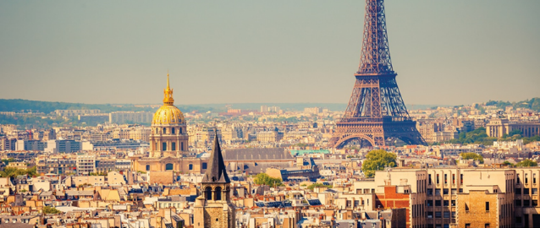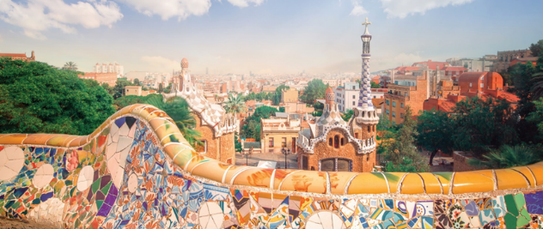
Paris & Barcelona Itinerary
March 8-17, 2018
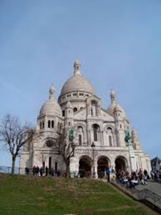
Day 1, Thursday, March 8 - We will board a charter bus after school (no school Friday), and head to Denver, where we will stay at an airport hotel.
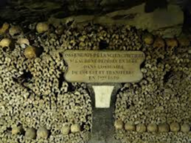
Day 2, Friday, March 9– We will take an overnight flight to Paris, France

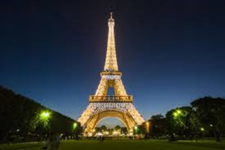
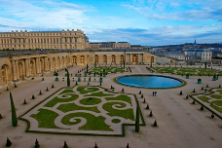
Day 3, Saturday, March 10 – We will meet our tour guide at the airport, load our own charter bus and set out to explore the sites of Paris. We will tour the famous Catacombs of Paris in the afternoon. After dinner, we will take the metro to Montmarte, where we will climb to the top and see street performers, artists, a beautiful cathedral, and enjoy authentic crepes.
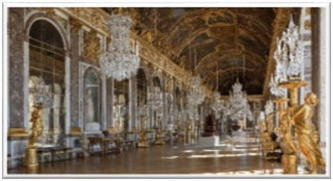
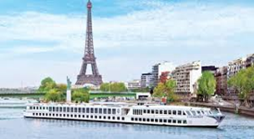
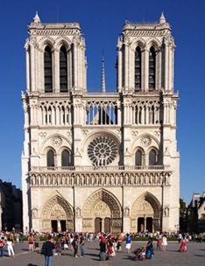
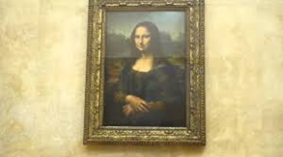
Day 4, Sunday, March 11– A local Parisan will take us exploring through the city in the morning, then we will make our way to the grand palace of Versaille for a guided tour of the home and gardens. Afterward, we will return to Paris, participate in an sunset river cruise on the Seine, and dock at the base of the Eiffel Tower where we will climb more than 800 stairs to the top of the Tower, and see the lights of Paris lights in all their splendor.

Day 5 – Monday, March 12- We will start our day with exploring the Louvre, then walk across the Seinne River to the Notre Dame Cathedral, where we will walk inside and discover its history.
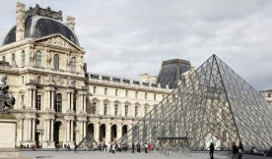
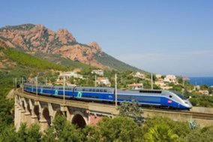
Day 6 – Tuesday, March 13- We will travel by TGV train through the European countryside to Barcelona, where we will take a walking tour of the city.
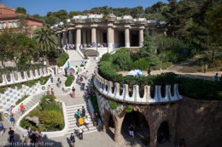
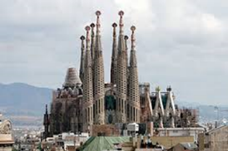
Day 7 – Wednesday, March 14- A local guide will take us on a walking tour to see La Sagrada Familia, Park Guell, Barrio Gotico and the Barcelona Cathedral. That evening, we will stroll Las Ramblas, which hosts street vendors and performers.

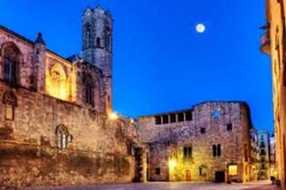
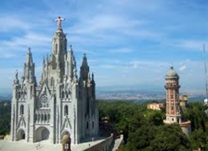
Day 8 – Thursday, March 15- We will begin the day with an inside tour of La Sagrada Familia and listen to the history of the uniquely designed castle. We will also walk through Park Guell, where we will have the opportunity to rent paddle boats, walk through the glass house terrarium, and have lunch in the gardens. That evening will be spent having dinner in the Barrio Gotica.
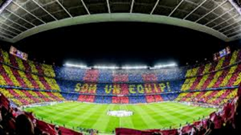
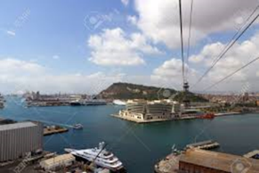
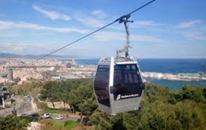
Day 9 – Friday, March 16- We will begin our day with a guided tour of the Camp Nou Futball Stadium. We will live the thrill of entering the field of play from the tunnel, and see the five European Cups. Afterward, we will be dropped at the top of the Montjuic cable cars, and ride straight down to the beach. Once there, we will have lunch, stroll the white sands, shop and explore until we are picked up to go back into the city for dinner.

Day 10 – Saturday, March 17- We will depart Barcelona, and fly back to Denver, where we will be met by our chartered bus and returned to Grand Junction.

